CS 226

Computer Organization and Design

Fall 2024

Assignment #5

Assembly Language

Sequential Programming, Basic Arithmetic & Logic Operations

Due date: Friday, September 27, 2024

This assignment is based on the assembly language concepts and instructions discussed in class through 9/18/2024. Start with the original shell program and modify it to implement this assignment.

______________________________________________________________________________

Step 1: the table below lists the values to define in the .data segment of the program.

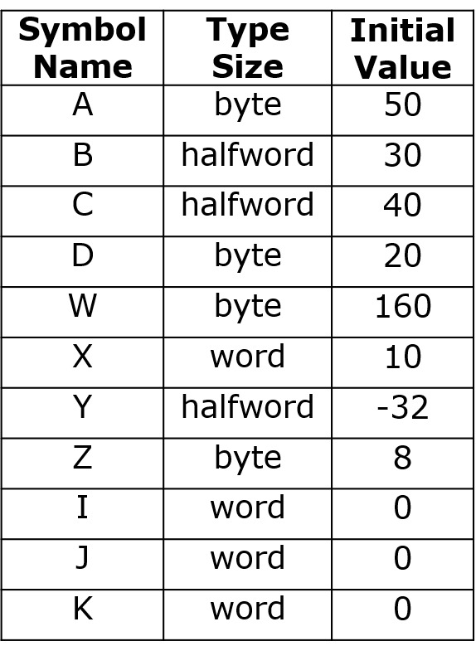

Step 2: create a sequence of instructions in the .text segment that calculates the following equations:

In the equations above, the symbol is a logical right shift and the symbol is a logical left shift. The shift is applied to the value that precedes it in the equation or the calculated value immediately preceding it.

The calculated values for *I*, *J* and *K* are to be stored into the allocated memory locations defined for them in the .data segment. These are the only values that should be stored.

Include comments in the .text segment indicating the beginning of the code sequence for each equation and where you are in the calculations after each instruction. Other comments may be added as appropriate.

Remember to work out in advance how you plan to use the registers and create a register usage comment section to include in your program just before the .data segment.

Some values initially loaded into registers may not be needed for subsequent calculations. You can reduce the number of registers you need for data by reusing a register for a different value. For example, if a value is only used in the first equation, the register initially used for that value can be reused for another value that needs to be loaded for the next set of calculations. Such reuse of a register is necessary when the number of data items exceeds the number of registers available. This register reuse can be documented in the register usage list simply by indicating all the values associated with the register.

To provide an example, the values for *B*, *C* and *D* in the first equation are not needed for the next equations. Therefore, the registers used for these values can be reused for values needed in the second equation. You simply load the new value into the register which overwrites the previous value. Just make sure you don’t inadvertently reuse a register containing a value that is still needed for subsequent calculations.

When you have completed your program, assembled and run it, create a memory dump by following the instructions in the video accompanying this assignment. Edit the memory dump to highlight the three values *I*, *J* and *K* and label them.

______________________________________________________________________________

Submit on Blackboard your assembly language source code program file and the memory dump file. Make sure you have saved your assembly language program with the .asm extension and the memory dump with the .txt extension.

______________________________________________________________________________

Grading criteria:

Header comments with description of program 5 points

Inclusion of a Register Usage List 5 points

Loading appropriate values from memory (correct offsets) 10 points

Correct instruction sequence for equations 10 points

Appropriate comments in text segment 5 points

Correct program results 5 points

Memory dump with highlighted result values 5 points

Total points for assignment 45 points